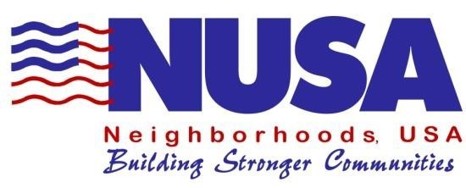

Running for Neighborhoods, USA
Board of Directors

If you are ready to make a difference by helping to build stronger, healthier and safer communities and neighborhoods, now is the time to consider serving on the Board of Directors for Neighborhoods, USA (NUSA).

Neighborhoods USA has a 21-member Board of Directors. Members of the Board of Directors are elected to serve 3-year terms and are elected by the NUSA membership during the annual conference held in May.

For the next NUSA board election cycle in May 2024, there will be nine (9) board member vacancies for a 3-year term beginning October 1, 2024 and ending September 30, 2027.

Application Requirements
The application shall be typed in the fillable form and emailed to
boarddevelopment@nusa.org.

Applicants must also email a high-resolution color photo with the attached Board of Directors Application Form. The candidate photograph should be a (2” x 3” or 3” x 5”) .jpeg, .gif or .png file. Please note the photo submitted with your application will be used in various NUSA conference and newsletter publications issued to promote the conference as well as all candidates running for the board. Photocopied or faxed pictures will not be accepted.

Board Candidate Eligibility Criteria:
Prior to becoming a candidate and being placed on the ballot, individuals interested in serving on the NUSA board must meet the following eligibility requirements:
- Must be a member in good standing of NUSA.

- Must be a member of the organization at least one year prior to becoming a candidate.

- All prospective candidates MUST have attended one previous NUSA conference within the last 3 years held at Ft. Worth (virtual); Little Rock or El Paso, and MUST have attended at least one of the “Running for the NUSA Board” workshops held during one of the previous three (3) NUSA Conferences, or must be an existing board member in good standing who is eligible to run for re-election.

- Per Section 6.C.ii of the NUSA bylaws, “There shall not exceed more than two (2) members of the Board of Directors from the same city, and no more than three (3) members from the same state.”

Board Candidate Rules and Board Member Expectation:
- Candidates MUST attend the opening breakfast during the annual conference.
- Candidates MUST attend the Saturday closing luncheon during the conference
- Candidates MUST attend the Saturday Business Meeting during the annual conference.

- Board members must attend at least two of the three annual NUSA board meetings (including the pre and post board meetings at the annual conference) at your own expense. Travel expenses will not be an acceptable excuse for board meeting absence.

Board Duties:
NUSA is a working board, and as such, committees as well as individual board members have duties and obligations that must be fulfilled. Below is a list of NUSA’s standing committees and typical duties:
- Awards Program Committee – Responsibilities include but are not limited to the administration of all aspects related to the existing NUSA awards program including the annual update of award applications, solicitation of award applications, facilitation of judging and the award presentations.

- Board Development Committee – Responsibilities include but are not limited to reviewing and updating the NUSA Board Manual and all election forms on an annual basis, development and implementation of all election procedures, monitoring and facilitation of board elections, and providing orientation for new board members.

- Membership Service Committee – Responsibilities include but are not limited to development of membership cards, responding to membership service requests and oversight of the NUSA Affiliate program.

- Program Development Committee – Responsibilities include but are not limited to oversight of the conference host city’s plans for the annual conference, reviewing the Host Entity Bid Packet and facilitating the Host City selection process.

- Public Affairs Committee – Responsibilities include, but are not limited to promoting NUSA, responding to media requests and oversight of NUSA communications via print, web and social media.

- Bylaws and Rules Committee – Responsibilities include but are not limited to annually reviewing NUSA’s bylaws and standing rules, updating standing rules for consistency with the NUSA bylaws, recommending NUSA bylaw edits, and validating motions and resolutions submitted to the Board for general membership approval.

- Resource Development Committee – Responsibilities include but are not limited to researching and reviewing opportunities for financial partnerships, sponsorships and donations.

If you feel that Neighborhoods, USA is a fit for you, please complete the Board of Directors Application Form below and email your completed application and picture to boarddevelopment@nusa.org by February 1st, 2024.

If you need assistance or you are unable to email your application, please contact the Board Development Committee at: boarddevelopment@nusa.org.

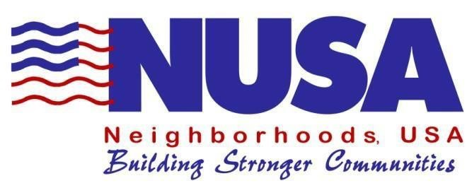
Board of Directors Application Form
Please type in information below or print legibly.

Applicant’s Name: ________________________________________ _____

Applicant’s Street Address: ________________________________________________

City:______________ State: __________________ Zip Code:

Organization/Agency/Business Affiliation: ___________________________________________

Work Phone Number: ______________ Home Phone Number: ____________________

Fax Number: _______________________ Email: _____________________________

Check one (1) category that best describes your category of representation for the Neighborhoods, USA (NUSA) board:
Business or Institution City or County Employee
Elected City or County Official Neighborhood Volunteer

Indicate below the previous NUSA conference(s) attended within the last (3) years:

Criteria: An applicant must be able to answer YES to the following questions in order to be eligible for candidacy:

 | YES | NO
Is the applicant a current member of NUSA?
Has the applicant been a member of NUSA at least one year prior to becoming a candidate?
Has the applicant attended a Running for the NUSA Board workshop?
Applicant understands to ensure a regional balance, as well as an equitable representation of all community interests, there shall not exceed more than two current board members serving from the same city?
Applicant understands he/she must be able to attend meetings of the NUSA board at his/her own expense.
Does the applicant agree to participate on the NUSA Board Committees?
Will the applicant be present during the opening breakfast?
Will the applicant be present during NUSA business meeting held after close of the conference on Saturday?
Will the applicant be present during the closing luncheon?

Complete the following section(s) that apply to you:

Affiliation and Experience:

Community Volunteer: Indicate the community organizations that you have volunteered with and your position in the organization.

Professional Community Support Staff: Indicate your title and provide a brief job description. Also describe any other related professional experiences.

\

NUSA publishes candidate information in its spring newsletter prior to elections held during the annual conference. For publication purposes, in 125 words or less, please state why you believe you will be an asset to the NUSA Board of Directors and include any professional or community experience and/or affiliations that you may have.

